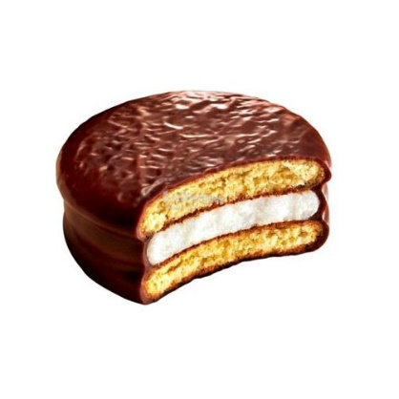
Introduction
A smooth and less dense frappe is a prerequisite for getting a good quality marshmallow.
HIFOAMAID®92 is a dairy based protein powder that imparts excellent smoothness and aeration to the frappe, which in turn improves marshmallow quality.

Benefits

- Egg and gelatin replacement
- Improved frappe smoothness, softness and appearance
- Reduces density of frappe substantially to 0.4 to 0.6 g/ml
- Maintains foam structure for 60 minutes

Application Conditions

- Add HIFOAMAID®92 at a dosage of 2-3%.
- Weigh liquid glucose, sugar & water and melt @70˚C to form a homogenous sugar syrup.
- Add melted sugar syrup and HIFOAMAID®92 into the planetary mixer.
- Whip at a speed of 250 rpm for 2 min initially and at 450 rpm for a total of 15-20 minutes.
Storage Conditions & Packaging:
- HiFoamAid®92 MUST BE STORED at temp. 25±5°C and 35% ±5% humid conditions
- It is best if used before 12 months from date of manufacturing.
- It is available in 25KG PP bags

All our products, conform to the standard FSSR, 2011 (The food safety and standard regulation, 2011 as amended by regulations, 2016)
FSSAI LICENSE NUMBER – 10015043001372
PRODUCT DATA SHEET
PRODUCT | : | HIFOAMAID® 92
VERSION No. | : | 1.0 | DATE: 14-04-2026



The information contained herein is true and accurate to the best of our knowledge and is offered in good faith. Recommendations are to be optimized at every stage since the conditions and method of use, are specific and beyond our control.

